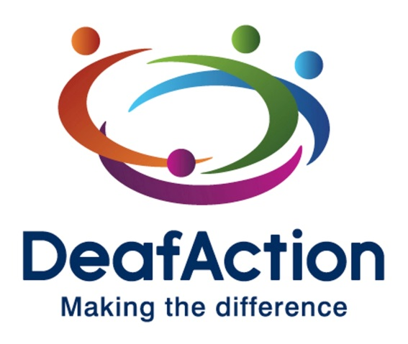
Family British Sign Language course

This non-accredited course has been designed for families with a Deaf child up to 8 years old who wish to learn BSL together.

Course information

Cost

Thanks to funding from Santander, the Birkdale Trust and the Souter Trust we are able to offer these courses to families of Deaf children free of charge!
Course Content
Throughout this course you will cover various topics including (but not exclusive to): fingerspelling, numbers & time, family and home life, animals and pets, travelling, holidays, food & drink, hobbies, activities, clothes and giving instructions.
You will also begin to learn how to structure sentences using BSL grammar and syntax, begin to use non-manual features (facial expression and body language) and learn how to describe the placement of objects, rooms within buildings and people.
Course Structure
We understand that children and adults require different teaching styles so we try to incorporate this in to the classes.
We use a mixture of games, crafts, picture books, toys, stories and other visually stimulating methods to teach. This visual method is effective in allowing the children to easily associate signs with their meanings.
The adults will join in with these activities so you are also learning through play as well as having some time with the tutors.
Our tutors are Deaf BSL users themselves and are very experienced in teaching absolute beginners through to advanced students of all ages.
Application instructions
To apply for a place on this course simply fill out the next page of this form and return it to us. The best way to do this is by email to learn@deafaction.org. You can also post it or hand it in to the Deaf Action Head Office addressed to: Lauren McAnna, Deaf Action, 49 Albany Street, Edinburgh, EH1 3QY
Family BSL course
Initially, we are having to limit places on the course to 1 Deaf child and 3 family members per family. If it is getting close to the start date and the course still has available places, these will be released on a first come first served basis.

 | Name | Relationship to Deaf child
Deaf child
Family member 1
Family member 2
Family member 3

Contact details

Parent / guardian name
Contact number
Email address
Emergency contact name
Emergency contact number

Which course will you be attending? (chose only 1)

☐ 2nd Feb 2019 – 6th April 2019
or
☐ 27th April 2019 – 29th June 2019

Additional information

Are there any learning requirements you would like the tutor to be aware of? (e.g. dyslexia - coloured paper handouts, sight problems etc)

Does anyone participating in the course have any disabilities you would like the tutor to be aware of?

Is there anything else you would like the tutor to know before starting the course?

Privacy statement
Deaf Action will use the information supplied by you in this form for the purposes of this course only. Only the Training & Quality Management officer, the Training & Communication Manager and the tutors will have access to this information. It will not be shared with any external 3rd parties or any other departments within Deaf Action.

Declaration

Sign and date below to declare that you have read and understood everything on this form, including the privacy statement.

Signature:

Date:

